Charles Payne
by
Rhonda Brownlow and Monica Jones
brownlowr@dodo.com.au

CHARLES PAYNE was born 26 Dec 1819 in Orpington, Kent, England, the son of James Payne and his wife Elizabeth nee Town.

Charles Payne was one of those who elected to make a new start in the Colony, because of the possibility of a brighter future. He was one of those on board the James Pattinson. Arrangements were made by the agent Mr. John Marshall. The ship set sail on 26th August and arrived in Sydney 11th December 1838 a voyage of 106 days at sea. Charles had been given a good character reference by William Townley the Vicar of Orpington and Joseph Martin the Minister and his old school master Henry Chapman, as Charles had been educated and was able to read and write.
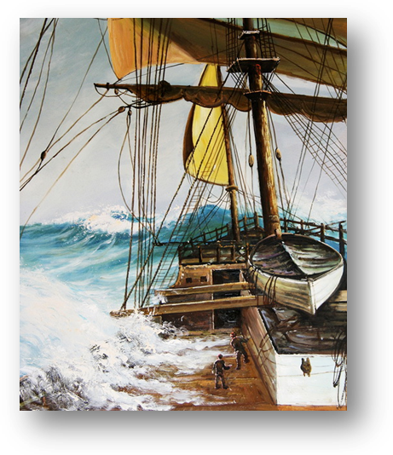
A Bounty ship of the high seas.

Ship News

The James Pattison, Captain Cromarty, arrived yesterday from England, with about 300 emigrants of the usual description, in good health; there were 5 births on the passage, and 11 deaths amongst the children. Captain Cromarty has been from this port only 10 months during which he was detained in England more than 3 months. The James Pattison, was becalmed on the line, and was under the necessary of coming round Van Dieman’s Land, and but for the detention would have made the voyage in 90 days. Captain Cromarty fell in with the Portland board, with 350 emigrants from Greenock, bound for Sydney, in the 6° north, on the 24th September. It is supposed, as the Portland is a good sailor, that she has put in at the Cape of Good Hope also fell in with and American vessel off the coast of Van Dieman’s Land last Sunday week, and again on Thursday last off Jervis Bay, apparently bound to these Colonies.

Bounty Immigration

Since many could not afford the expense of travelling to Australia, in 1830 the assisted passage scheme was initiated for British migrants. Rather than giving Australian land away to ex-soldiers (whose period of service had finished) and emancipists (convicts who had finished serving a sentence or been granted a pardon before their sentence had expired), this scheme required the purchase of colonial land. The proceeds from land sales were then used to pay for the passage of poorer migrants to Australia. By 1850 around 187000 free settlers had migrated to Australia, most of who had arrived under the assisted passage scheme.
Designed to attract young couples and young single women, the bounty scheme involved the colonial government of New South Wales paying shipping agents a bounty (reward) for each suitably skilled migrant that they were able to secure for employers. Shipping agents, however, were criticised for overloading their ships in a greedy attempt to make a greater profit. The bounty scheme was abandoned six years later.
Relief for the poor became urgent. In 1834 new Poor Laws led to the rise of Workhouses. The condition of village labourers continued to deteriorate until many reached such a state of despair that they were ready to revolt.
One factor contributing to the economic distress in the counties of southern England was the decline in the demand for English Southdown wool. This was being ousted from the market by wool from German sheep crossed with Spanish merinos.

This period became so distressing for agricultural labourers and tradesmen that the Parish officials began encouraging them to emigrate to N.S.W.
Standard foodstuffs on migrant ships were: - salt beef, pork1 flour, peas, tea, sugar, rice, raising and oatmeal. The migrants themselves had to provide clothing; bedding, personal articles and they were advised to bring some tools.
The Bounty Immigration Scheme was first suggested by Edward Gibbon Wakefield. He suggested that:
- The system of free land grants should cease and Colonial land should be sold.
- The revenue from these sales should be used to boost emigration from the U.K.
- Certain conditions should apply to the type of emigrant accepted.
This scheme was gradually adopted. The first set of Bounty Regulations was gazetted by Governor Bourke in October 1835:
- The persons accepted should be mechanics tradesmen, or agricultural labourers.
- They should have references as to their character from responsible persons, such as the local magistrate or clergyman.
- To prove their age they should have Certificates of Baptism.
At first, before 1835, the passage money was advanced to emigrants by the Government, to be paid back out of their salary, but many refused to pay it back, so the Government converted this Loan into a Free Bounty.
Settlers in N.S.W. were allowed to recruit their own workers in the U.K. Most employed agents to do so. The Government also had an Agent-General in London after 1837, and Agents in other embarkation ports.
Under the Bounty Scheme the settler who wanted workers paid the Emigrants' passages. On arrival these workers were examined by a Board appointed by the Governor and, if the Board were satisfied, the settler would be issued with a Certificate entitling him to claim the Bounty money back from the Government.
Complaints from the settlers before 1841 were uncommon. The Bounty was refused on only about 1% of applications, mostly on grounds of age.

The costs were:
- 30 pounds for a man and wife under 30 years on embarkation;
- 15 pounds for each single female 15y to 30y with the approval of the settler or the agent, and under the protection of a married couple or to stay with the family till otherwise provided for;
- 10 pounds for each unmarried male 18y to 30y (equal number of males and females mechanics or agricultural labourers were to be encouraged by the settlers);
- 5 pounds for each child over 1y.

FAULTS OF THE SCHEME
There were several faults in the Bounty Scheme:
- Settlers complained that not all migrants knew the trade they claimed;
- Not many settlers had the money to pay the Agents in the U.K. to act for them and the system soon fell into the hands of the ship owners or of speculators;
- There were not many checks to the system;
- The ship owners sometimes changed the arrangements;
- Discipline aboard ship was often neglected;
- The Agents In the U.K. created false impressions of life in NSW

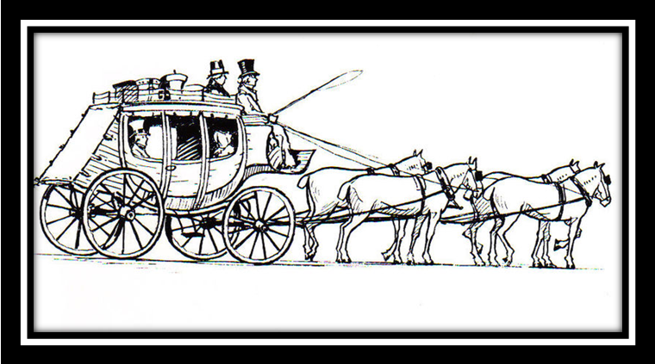

CHARLES PAYNE MARRIES

Charles was working for William Edge as a Coachman in Newtown Road when he marries ANNE ELIZABETH FITZGERALD on the 06 May 1839 in St James Church, Sydney rg 97/23. Witnesses to their marriage were Standish Barncastle and Elisha Hayes. Their residence was listed as Alexandria and they were married with permission of the Governor as Elizabeth was not yet free. Her master Captain Robert Lethbridge had a residence at “Flushcombe”, Parramatta which enabled Charles to meet Anne and the romance developed from there.
There is a Flushcombe Street, off the Great Western Highway.

ANNE ELIZABETH FITZGERALD:

Anne Fitzgerald Age 23 years, religion R/C, able to read but not write, a native of Limerick, tried Limerick City, sentence 7 years, occupation laundress and housemaid, crime was stealing a cloak, her physical description states she was 5’1 1/2”, with a ruddy freckled complexion, brown hair, blue-grey eyes, she had no physical scars. Elizabeth was granted her certificate of freedom in 1842/689. Assigned to Captain Robert Lethbridge at “Falbrook”, Patrick Plains (Singleton). Captain Robert Lethbridge arrived with his wife on board the Lusitania in May 1823. He took up a grant at Bridgman which was managed by Richard Alcorn who also had a smaller grant nearby. Captain Lethbridge also purchased Oakhampton Park at Maitland where he resided for several years

'Convict ship Thomas Harrison'
The ship 'Thomas Harrison' was a barque of 355 tons built in Sunderland in 1836, an A1 class ship, the ships Master Thomas O Harrison and Surgeon Henry Gordon Brock sailed on 19th February 1836 from Cork, a voyage of some 111days at sea. The ship sailed into Sydney Harbour on 9th June 1836 with 112 female convicts on board. Elizabeth received a 7 years sentence for theft of the cloak.

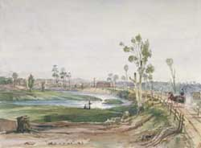

Heading along the great South Road to Goulburn

Charles and Anne take up their new life in Goulburn were he was either employed as a Coachman and or Publican, for which he held various licenses. He must have found sufficient means to set himself up as a publican from his earnings as a coachman and side trips for fossicking goldfields in Forbes, Lambing Flat and Abercrombie. After his wife Anne died in Goulburn, he then worked as a dealer or gold digger, until he decided to try and pass a cheque from the ill gotten gains of Ben Hall’s bushranger gang after a visit to his son -in-law Alfred Cramp.

Charles Commits First Offence

In 1844 we find Charles was only 23 he was locked away in Berrima Gaol but no record of the offence committed can be found fortunately we have our first physical description of Charles. He was 5’7” tall, stout build, with a sallow complexion, brown hair and hazel eyes. The only distinguishing mark was a cut on his left wrist.

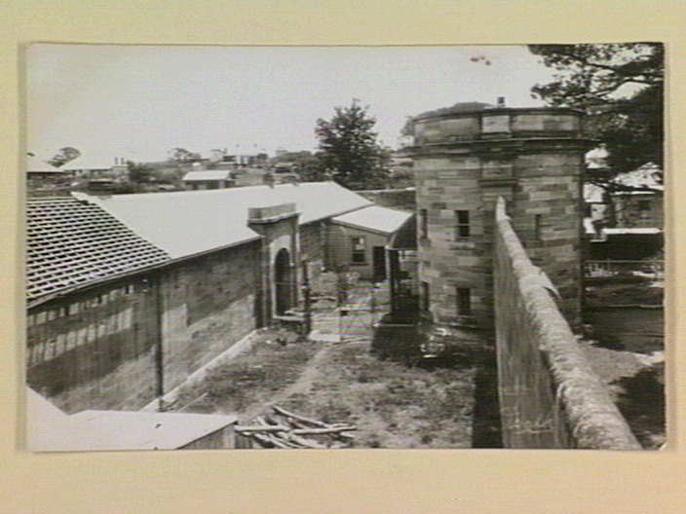

Berrima Jail

Charles Incarcerated in the Notorious Berrima Prison

Governor William Small was a brutal, sadistic man. He became Governor of Berrima Jail. On his inspections he carried a wooden club and any prisoner who did not please him was likely to have his ribs broken with a few well delivered blows. Tales of his alleged brutality leaked out and a Commission of Inquiry was appointed. The commissioner reported it was impossible to believe evidence of convicts, so nothing was done.

William had joined a whaling ship when he was a lad, spent some time at the Islands and in the South Seas and afterwards had some experience as an officer in Darlinghurst Jail. He was a great disciplinarian and in some cases considered to be too severe; As soon as a troublesome prisoner was willing to submit to the rules I think he had no cause to complain. It certainly took a sharp man to manage some outlaws.

As an instance of what he had at times to contend with I might say that, on one occasion, the greater number of prisoners took it into their heads to shout, curse and swear, for three days, almost without ceasing. It was very disagreeable to the inhabitants of Berrima who could not shut out the disturbance. The jailer had no power to stop them. The sheriff was called up from Sydney but was equally helpless. To get away from the intolerable noise he came to my house to have tea, being an old friend of mine and whilst there he was with me when a warder came with the message from the jailer that if he was not empowered to stop the noise he would resign his office.

Mr. Small had in the meantime had a number of gags made of a piece of wood with a hole through it, to be placed in the mouth and a leather strap, which buckled behind the neck. The warders handcuffed the lags behind them, and then gagged them with chunks of wood that were so fiercely stuffed into their mouths that the men's flesh was severely lacerated. The gag caused dreadful pain, in a little time, to the wearer, but no voice could be raised.
The gag left no pain or inconvenience, from the moment it was removed from the sufferer, but it was ready as a warning to the wrongdoer"

The sheriff was afraid to sanction its use, for neither the gag nor flogging had been authorised by the Government. At last however, when he received the jailer’s message, he very wisely sent back word by the warder virtually giving permission. “Tell Mr. Small,” he said “to do whatever he thinks proper, and I will be answerable for his action.”
The gag left no pain or inconvenience, from the moment it was removed from the sufferer, but it was ready as a warning to the wrongdoer"
In Old Australia
Rev. James Hassell
Page 95, 96

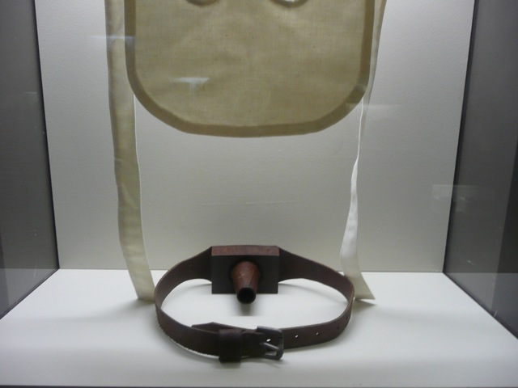
The Gag and Mask

Larry Cummins the bushranger used to feign madness as one of his ruses and William Small admits to horse whipping Larry for -"shamming madness' Small said he struck Cummins about the legs with his riding whip but didn't mark him. He called the doctor, who put Larry in a straight jacket. Larry later reported Small to the Comptroller-General of Prisons over the incident. Small admitted to having threatened to gag Larry (with the wooden gag of his invention) for being abusive.

There is reference in the minutes to Larry complaining that he had two of his teeth knocked out. The Reverend Father McGuinn, The Roman Catholic Chaplain, saw evidence of this next morning, but thought it was not by a gag but by a whip stroke to the mouth -with the whip handle one supposes.

When Small was told that a prisoner called Hughes had given evidence that he had known Small to knock Larry down for smiling, Small said: “it is false Cummings has written me twelve or thirteen letters from a station he was at near Singleton. He said that he would never forget me for my kindness to him and that if he even met a dog of mine in the bush he would feed him"

An ex-warder called James Hill gave evidence that "Cummings" was gagged on several occasions. James Henry, a prisoner in Berrima Goal stated that he saw Cummings gagged for "mutinising" and that Small and some of the officers knocked him down and caused cuts to his head and face.
It's A Long Way From Tipperary
Maurice Cummins
p70-71

The Royal Commission concluded:

The two main complaints about their cruelty were the spread eagling and the gag.
"It must be admitted that the chaining of a man to the walls of a cell is a barbarous means of punishment, which should not be tolerated as a means of punishment and there should be no necessity for reporting to it as a method of restraint".
"We desire to see no further instance of the chaining of a prisoner to the walls of his cell and we beg to recommend that the ring bolts be removed.
The committee recommended strict limitations of the use of the gag, which was an instrument designed to temporarily silence difficult prisoners.

In 1886 William was made Governor at the new jail at Trial Bay, near the mouth of the Macleay River, with 23 warders and Dr. Casement as jail doctor.

Misfortune befalls the family with the sad death of their daughter Emily in 1949.

Goulburn Herald
Saturday, April 21, 1849.

Fatal Accident;- On Wednesday, a little girl aged 3 years, daughter to Mr. Charles Payne of this town, was severely burnt through her clothes catching fire. She lingered until yesterday, when death put an end to her suffering.

EMILY PAYNE:
Baptism: Goulburn her father was a coachman
Burial: 22 Apr 1849, St. Saviour's Anglican Cemetery Goulburn

GOULBURN GOLD FIELDS. (From our own Correspondent.)
Empire (Sydney, NSW: Wednesday 29 October 1851 p 2 Article
Charles Payne at Abercrombie Diggings
Charles Payne has brought into, town about 9 ozs. the produce of two or three weeks' digging. He had dug deeper than any of the others at these diggings, having sunk a shaft eleven feet deep. At that depth he found gold of heavier grain than near the surface, and in larger quantities. On his road into Goulburn he picked up two nuggets on the summit of a hill near Tuena, about 50 miles from here.

Goulburn Herald
November 17, 1852

Charles Payne has taken over the premises known as Lord McDonald, corner Verner & Auburn Streets, Goulburn which he intends to open as The Gold Diggers Arm Inn.

Goulburn Herald
Saturday, December 18, 1852.

Notice of Removal;
Charles Payne Takes the earliest opportunity of informing his friends & the public, that he has taken the premises known as Lord McDonald, situated at the corner of Verner & Auburn Streets, which he intends to open as an Inn, as soon as a licence can be obtained, until such time, he will be happy to entertain his friends as heretofore, & has the satisfaction to inform them that the premises are very convenient & will enable him to afford every accommodation & comfort to those who give him a trial, having excellent stabling, & in fact every convenience for man & beast

Goulburn Herald
Saturday, March 5, 1853

Charles Payne begs to inform his friends & the public generally, that have been disappointed for the present in obtaining a licence for the house he now occupies, being the

Lord McDonald Inn
Auburn Street
He has never the less every comfort & convenience for parties passing through Goulburn; & shall be glad to prove, by civility, attention & moderate charges, that he is deserving their patronage & support. Excellent & extensive stabling, Coach House & large yard for teams.

Goulburn Herald
Saturday, March 19, 1853.

Land sale at Goulburn,
On Wednesday 16th instant, a sale of land was held at the Court House, Goulburn.
Town lots -Lot 3, 2 rods, Charles Payne - ₤38.10 pound.
Country lots -Lot 53, thirty acres, William Payne - ₤30.00 pound.

Goulburn Herald
Saturday, April 23, 1853.

Grant of Licences
On Tuesday 19th instant, a Court of General Petty Sessions was held in the Police Office, Goulburn for the purpose of taking into consideration a licence of Charles Payne. Licence was granted on 26th April 1853 for the “Gold Diggers Arms” in Auburn Street, Goulburn.

Robbery at Lord McDonald Inn
Goulburn Herald

George Bailey, late f Goulburn, in the colony of New South Wales, was indicted for feloniously stealing at Goulburn aforesaid, on the 5th January last the sum of ₤7, and one watch, of the goods and chattels of Charles Payne.

The prisoner pleaded not guilty, and was defended by Mr. Purefoy: attorney, Mr. C. H. Walsh.

The Solicitor General stated the case, and called Charles Payne , from the evidence it appeared that he is publican , residing in Auburn Street, Goulburn; knows the prisoner; saw him in his house on the 7th or 8th of January last; I was at the bar when I saw the prisoner going out the back door, pass the kitchen, and then throw something over the wall; I did not see what it was; it was something small; was close to him as he threw it over; the wall is about 6 or 7 feet high; I called to the prisoner and told him to give me up what he had; this occurred between 7 and 8 in the morning; prisoner came back into the house, and I then searched him; I can’t swear to the watch; never took notice of it.

Anne Payne, called and examined-is the wife of the last witness, saw the prisoner, at the bar of her public-house, on the morning of the 6th January last; I asked prisoner what business he had at my bedroom door that morning; he said it was a mistake. I did not see him at the door; I saw my husband go out and come back with the prisoner; after that he was given in charge to the constables; after he was taken, I found a purse close to the water cask, it contained 7 sovereigns, and it was the same purse that was in my room; I did not see the purse that morning.

Jonathon Cotton, called and examined-is groom and hostler, at Mr. Payne’s; was cutting wood in the yard at Mr. Payne’s the morning prisoner was apprehended; saw him throw something over the wall; cannot say what it was ; I went round and found the watch nearby sixty yards form where it was thrown .

Richard Hall, sworn and examined-saw prisoner coming out of Mrs. Payne’s bedroom the same morning he was apprehended did not see anything in his hands; there were several other persons in the house at the time; prisoner was rather tipsy.

This was the case for the Crown.

Mr. Purefoy very briefly addressed the jury, and his Honor having summed up the jury found the prisoner not-guilty- and he was discharged.
The second misfortune befalls Charles when his wife Anne dies at Towrang on the 26 January 1854. She was buried in the St. Saviour's Anglican Cemetery Goulburn on 27th January 1854.

Christmas Ball at Binda

26th December1864 saw the gang arrive in the vicinity of the little village of Binda, where a Christmas Ball was to be held. They entered the village form the Goulburn side in company with three local girls, Ellen Monks (who was aged 17), Margaret Monks (aged 19) and Christina McKinnon (who was 25).

It will be remembered the Monks girls whose mother was hanged for murdering their father and their brother James, who was convicted of horse stealing, being involved in assault, and was also charged with robbing the Tuena mail man.

Owing to Christina McKinnon’s sister being married to one of the Hogans, she was related to the Vardy, Monks, Berrell, Cummins, Francis, McGuirk and Shepherd.
It was eight o’clock in the evening when Mr. Morris, the owner of the Flagstaff store, was out walking in his paddock and saw a group of three men and three women approaching the village. As the people neared the paddock, Morriss saw the men, who were mounted, diverted along side the paddock fence, while the women proceeded into the village proper.

In Morriss’s store at this time was his wife Mary and before the storekeeper could return to his business, the three girls, who were carrying their side saddles and riding skirts, entered the building, undoubtedly they had left their horses outside the village and also changed from their riding habits into ordinary dresses. The young women were all well known Morriss and his wife, as Ellen Monks had worked and lived with them for over a year.

The girls asked Mrs. Morriss for some crinolines and a few minutes after this Edward Morriss arrived back at the store, and on entering said “Ellen, are you putting on a crinoline?” About five minutes later Hall, Gilbert and Dunn walked in the front door saying “Bail up” to which Morriss replied “Alright.” Morriss recognised Gilbert as the person who was known by the nick-name of “Happy Jack.”

Ben Hall immediately went straight to a quarter-measure where the storekeepers kept their money, saying to Mrs. Morriss “I hear you keep your money in strange places”.
Undoubtedly he had been told of the container and location by Ellen Monks. After taking over ₤100 pounds from the quart-pot, the bushrangers who however were accompanied by the three girls, ordered Morriss and his wife to go with them to where the ball was in progress at Hall’s Inn (no relation to the villain).

On entering they bailed everyone up, and after telling all present that no one was to leave the building, the gang proceeded to enjoy themselves.

During the evening Joseph Hadfield (who had been a trooper in the old police) asked Ellen Monks if the bushrangers were her sweethearts, and she replied”Yes they are:” This was also evinced by the conduct of Hall, who was seen to be hugging Christina McKinnon and pulling her clothes up, and by Gilbert, who was kissing Ellen Monks, whilst Dunn was partnering Margaret Monks.

While the festivities were going on, Edward Morriss tried to organise some of the men present to rush the bushrangers, but none were game to try it. So finally, at about two o’clock in the morning, Morriss escaped through a side window, followed by a few shots from Gilbert. The storekeeper then went about 80 yards to some brush, which was mid-way between the Inn and the store, where he lay hidden, listening to what was going on.

Ben Hall was furious at Morriss’s escape, and shouted that he would “burn the bloody dog’s store down to the stump.” Mary Morriss begged him not to do this, but Hall replied that “it was all very fine” and then repeated it that he would “burn it to the stump.” Mrs. Morriss then tearfully asked the bushranger if she could first get her clothes out, begged him not to do this, but Hall said he would :”shoot her if she went outside” and would do the same to anyone else who left the building during the next hour.
Meanwhile Edward Morriss, who had hoped to get the gang’s horses, now had to move to another hiding place about 50 yards away on the other side of the road as the bushrangers and the three girls came out of the Inn.

From where he was, the storekeeper could hear what the bandits were saying, and heard Christina McKinnon say “Do, it Ben, it serves the bugger right.” To which Ellen Monks added “do it. Serves him right.”

The three villains and the girls no went to Morriss’ store, and after they removed their side saddles, etc. Christina and Ellen assisted the bushrangers to pile wood on the veranda of the building before Ben Hall set fire to it. Margaret Monks is reported to have said “save poor Mrs. Morriss’ clothes.” However this plea only caused Gilbert to report “The bastards has got lots of money in the bank—let him buy her some more.”

As his building and dwelling started to burn, Morriss, from the place of hiding, saw Dunn and Margaret Monks go and get the bushrangers horses from where they had been tethered. The two then stood talking on the road. At the same time Christina McKinnon and Ellen Monks, followed Ben Hall and Gilbert, walked into a patch in the scrub, which was 63 yards from the burning store, where they spent about a quarter of an hour together out of sight.
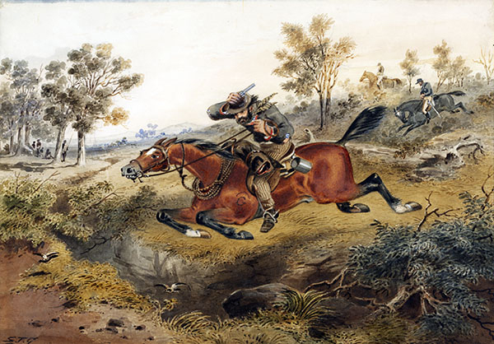

Ben Hall leading the gang away from Binda

The two bushrangers and the two girls came out of the scrub and moved down the road again, where Morris heard Hall say as he looked at the mass of flames which had been the store “That will teach the bugger to interfere with us.” The gang then went to their horses and the three girls were with them when Hall mounted up. The bushrangers then rode out of town past the Inn, while the girls got their side saddles and riding skirts and also departed the scene. Edward Morriss then went to Goulburn to report what had happened.

The following morning Joseph Hadfield (who was the pound keeper, and who had been visiting Binda on the night of the incident) found a pair of elastic-sided boots near the fence of Morriss’ stockyard
.
The Storekeepers lost was over one thousand pounds, as the building was totally destroyed. Plus, his account books, which carried debts of over five hundred pounds, were also incinerated. With no insurance in those days to cover such a loss.

Christina McKinnon and Ellen Monks were arrested and charged with assisting the bushrangers to burn down the Morriss’ store, and were committed for trial in Sydney.
Source The Sandy Creek Bushranger by Edgar F. Penzig pp 106,108

MONKS, Ellen and McKINNON, Christina
SMH 1865

Both Christina McKinnon and Ellen Monks were found by the police and arrested and were charged with assisting Ben Hall and his gang to commit the crimes, in Binda on that Boxing Day night. Margaret Monks had also been arrested, however for some reason; it was decided to drop the charges against her, as the authorities felt they had a better chance with only two defendants to try instead of three. Christiana and Ellen were sent to Sydney for trial.
It was in early July in 1864, when Christiana McKinnon and Ellen Monks were tried before Chief Justice Sir William Foster Stawell in Sydney, on the charge of aiding and abetting arson on the store owned by Edward Morriss in the village of Binda in the early hours of 27th December, 1864. Evidence of what occurred that night was given my Edward Morriss, who made a very good witness. The jury however, was having difficulty with their verdict, so the Chief Justice informed the Jury he believed the story told by Edward Morriss to be substantially true and that the storekeeper was entitled to public thanks for a gallant effort to capture a gang of ruffians. Even though the Jury had found both the girls guilty of point one of the two charges, the Chief Justice discharged both Christian and Ellen, advising them. "to free themselves from all association of the character of the type they were messing with." He placed them on a bond of one hundred pounds each. The Chief Justice warning them not to seek the company of the scoundrels again, or they would find themselves before the Court and no such leniency would be
given to them a second time. It appears that the girls took the advice of the Chief Justice. Christina McKinnon married David Totten in 1875 and had two children David and John. Ellen Monks would marry Daniel Shepherd.
While the girls stood trial for their participation in the hold up and burning of Edward Morriss' store, the three men with them that night, Hall, Gilbert and Dunn, had escaped arrest and continued on their robbing ways. On the 30th December only four days after the Binda Boxing Day Ball, they held up a David Davis, the auctioneer from Yass, who was on his way home, and stole from his money bag. However much to the disgust of Ben Hall most of what David Davis was carrying were cheques, and only a very small amount of cash. However, Gilbert was able calm down the situation by suggesting to
Hall they ride into town and cash the cheques, before they could be reported missing. They then rode off, leaving David Davis unharmed. The cheques, however, were never presented at the bank, so it appears they had second thoughts about riding into town.

The year 1865 was a very wild one for Ben Hall, Gilbert of Dunn, which would not end very well for any of them. On 10th January they stole two more race horses at gun point, near Murrumburrah from a groom who was exercising them for his employer. They then went on to rob the "William Ford" Inn just outside of Tuena, not satisfied with their haul they robbed a store owned by the name of James Christie, however when they searched the store and his living quarters they found there was nothing worth stealing. On 21st January, they stole the racehorse "Young Waverly" and another two thoroughbreds from the Willoughby property. On 24th January the gang lay in wait for the mail coach coming from Yass on its way to Goulburn, however unbeknown to the gang, two of the passengers on board were armed police constables escorting a lunatic. When the gang fired on the coach calling out to halt as it was a hold-up, to their surprise they were fired upon from the coach. John Gilbert returned fire, however the gang very quickly realised this would not be an easy hold-up, so they rode into the surrounding bush to hide. After a discussion they agreed it would be a good idea to ride into Gunning and hold up the patrons at "Bean's Inn", which they believed would be much easier pickings.
On the 26th January, (Australia Day), Hall, Gilbert and Dunn celebrated by holding up every traveller they came across on the road south of Goulburn. However, once again their dastardly plans were undone, when a party of mounted police who had been alerted to the gangs presence in the area, arrived on the scene and began firing at the bushrangers. Once again the gang rode off on their stolen thoroughbred horses, leaving the mounted police in their dust, as the police horses were no match to the ones being ridden by the outlaws. Frustration must have been getting the better of the three desperados, as they were being foiled at every turn.
Some hours after they had been driven off by the troopers, they found they were on the road to Collector. As they rode along they came across a party of at least five settlers and took them prisoner, making them walk in front of the horses, while the bushrangers held their pistols on them. They arrived in the village of Collector in the late afternoon and made their way to the Commercial Pub, as it had been a thirsty day for the felons, and there may be good pickings to be taken from the patrons inside. They proceeded to rob everyone present. However, in their haste the gang did not notice a young girl watching them, and when she realised a robbery was taking place, she ran to the gaol to alert Constable Samuel Nelson, telling him that Ben Hall and his gang were in town, and were in the process of robbing the patrons at the pub.

Goulburn Herald,
February 1865

On Sunday last an affray occurred between the Police and the bushrangers, which has not been made public, though the news reached reporters last week. It seems that Hall, Gilbert and Dunn called at Alfred Cramp’s farm, on the Crookwell NSW, near Binda in this district, and ordered dinner. While the party of Police headed by an Inspector, whose name has not transpired, and Detective Jaggers, and numbering five in all, including one or two volunteers. They were perceived by the bushrangers or by someone on the lookout, and the Police perceiving that this was the case, dismounted, as there were some fences between them and the house. They then rushed up on foot, but too late to prevent the bushrangers mounting horses. Several shots were exchanged but the bushrangers escaped.

(One of the volunteers was later reported to be William Eldridge of Binda)

Police Gazette

25th March 1865, This charge was the result of a saddle claimed to have belonged to the Bushranger Johnny Gilbert, which had been stolen and found on the verandah of Alfred Cramp with another saddle. Both appeared to have been recently used. Alfred claimed both saddles were his. George Cramp claimed that the saddle in question he had purchased at auction at the Lachlan some months before.

Goulburn Herald and Chronicle
Thursday – May 18, 1865

Before the police-magistrate and J.W. Bray, Esq. J.P
Charles Payne, out on bail on a charge of receiving and uttering a cheque, knowing it to be stolen, appeared upon the floor.

.It will be remembered that a cheque drawn by Mr. C.S. Oakes, which is part of the money stolen from Mr. Morriss the store keeper, when the bushrangers burned down his store, was traced into the possession of the prisoner. It will be remembered that the prisoner was seen at Cramp’s door when the bushrangers were at the house. When last before the bench prisoner accounted for the cheque coming into his possession by saying that he had received it form a man named Wilson, well known at Tuena as Little Jack Wilson. The evidence of Senior-constable Pagett and John McDonald was now taken, showing that no such person was known at Tuena. The bench committed prisoner to take his trial at the ensuing quarter sessions on the 18th September, and admitted him to bail.

Yass Courier
Saturday September 23, 1865

Receiving a stolen cheque
Goulburn Quarter Sessions
Wednesday September 20, 1865

Before Judge Meymott

Charles Payne was charged with stealing a cheque for $3. 13s. 6d. A second count charged prisoner with receiving the same, knowing it to be stolen.

The cheque in question was stolen by the bushrangers from Mr. Morriss's store at Binda, on the 26th or 27th of December last. Some time after Inspector Roberts came across the bushrangers at a house at the Crookwell NSW, belonging to Alfred Cramp, prisoner's son-in-law. The prisoner was there at the time. The police were on foot, and the bushrangers mounted their horses and got off, prisoner's sister first shaking hands with Dunn. Shortly after the prisoner stayed for a night at Sigg's public house, at Pejar, and paid Mrs. Siggs with a cheque which he stated was one of Mr. Oakes's, but Mrs. Siggs, being unable to read, could not of her own knowledge say by whom it was drawn. It was, however, clearly for the amount in question. Some days after Mrs. Siggs paid the cheque to Mr. Emanuel; and it afterwards returned from the bank as being a stolen cheque.

Prisoner was apprehended in Goulburn, and he then stated that he got the cheque from a man named Wilson, at the Crookwell NSW, whom he did not know, and didn't think anyone else knew.

Mr. Walsh, in defence; Contended that the cheque stolen from Morriss's had not been identified as that paid by the prisoner to Mrs. Siggs, although he admitted that it was the document now before the court.

Mr. Forbes replied, and his Honor having summed up, the jury retired.

While considering the verdict, and while the succeeding case was being proceeded with Byrne, one of the jury in the Payne case was mentioned as having conveyed a message from the prosecutor, and the judge called Byrne from the jury room and questioned him on the subject.

After a short absence the jury found the prisoner guilty of receiving.
Mr. Walsh gave notice that in the morning he should apply for a new trial, on the grounds that his Honor having called Mr. Byrne from the jury room amounted to a separation of the jury. The prisoner was remanded for sentence.

The Goulburn Herald & Chronicle
Saturday, September 23, 1865

Charles Payne (on bail) was charged with having on the 27th December last at Binda, stolen a cheque, the property of Edward Morriss. A second count charged the prisoner with receiving the same, knowing it to have been stolen.

Prisoner pleased not guilty and was defended by Mr. Walsh.

Detective Pye: Deposed I apprehended prisoner in his own house, Clifford Street, Goulburn, on the 20th April; he was sober; I asked him if he had cashed a cheque at Siggs; he said he had; I asked if he remembered the amount; he said ₤3 odd, he thought ₤3.7s; I then told him I was arresting him for aiding and the bushrangers Hall, Gilbert, and Dunn by passing a cheque they had stolen; I then asked if he remembered in whose favor the cheque was drawn; he said in favor of Lachlan Robertson; he said he got it from a man named Wilson at the Crookwell who he thought had gone to Lambing Flats, that he didn’t know him himself and did not believe any one else did; he did not tell me when he got the cheque; Morriss was present at the time, and had the opportunity of hearing all that passed; I produced a cheque which I got in a letter from the manager of the Union Bank in Sydney; I did not describe the cheque to this prisoner.

To Mr. Walsh: I am sure prisoner said that no one else knew Wilson and am sure I said so in the police office; I believe prisoner was carrying business in Goulburn as a dealer; since I was with Morriss in prisoners house I have been a good deal in his company; I have had no conversation about what prisoner said at the time we went to prisoners shop.

Edward Morriss deposed: I now have no occupation; in December last year I kept a store in Binda; I know the prisoner; in January last he lived within about three miles of my store; my store was robbed on the 25 or 26 December; I saw him two or three days of crossing Binda Flat, within a hundred yards of where my store had been robbed; Hall, Gilbert, and Dunn robbed my store; there were a number of cheques and notes stolen; I remember them all; I remember a cheque for ₤3.12s.6d drawn by Charles S Oakes signature; the cheque produced is the same; the money was kept in a quart-pot, but I saw Hall with the pot in his hands; I did not see the cheque again till I saw it at the police office two or three months afterwards; I remember going to the prisoners place with Constable Pye; after I had pointed Payne out; Pye asked if Payne had passed a cheque Mrs. Siggs; after some hesitation Payne said he had; Pye asked from whom he got the cheque; Payne said from a man names Wilson; Pye said do you know Wilson – Payne said “I don’t know him myself, and I don’t believe any one else does; I saw the cheque in the quart-pot half and hour before the bushrangers came.

To Mr. Walsh: I have known prisoner for some years; he usually resided at the Tuena diggings; he came o the neighborhood of Binda about the time of the robbery; he lived at his son-in-laws Crams; I used not to see him at Cramp’s but about the public house drinking , and he used to go in the direction of Cramp’s; before the bushrangers came to my house two girls came , and were engaged in making some purchases from my wife in my presence; I did not leave till the bushrangers took me out; I was out when the girls first came in; before the bushrangers took me away I saw one of then in possession of the quart-pot ; in the course of business my wife had access to the pot, but never gave change out of it; I never gave her permission to give cheques out of it and she never did, I mean as a rule; Payne was selling apples; he was formerly a publican; when on Tuena Creek he was a digger; I did not know his wife kept a shop there; I have been much in Pye’s company since prisoner was apprehended I had no conversation with Pye relative to Payne saying that he did not know who Wilson was.

To his Honor: The purchases made by the girls who came into my store before the bushrangers did not require change from the quart-pot; one paid 5s and the other has never yet paid; no other person came in.

To Mr. Forbes: I was looking through the slabs and saw what the girls were doing; I saw then trying on crinoline; the girls were Ellen Monks and Christina McKinnon.

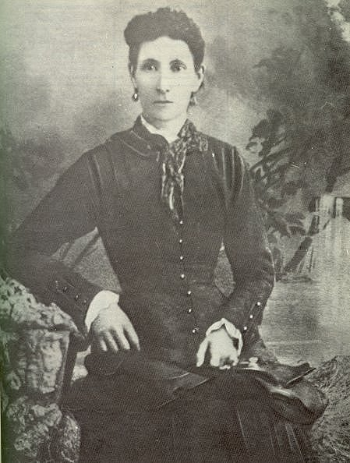

Christina McKinnon
(with Ellen and Margaret Monks at the time of burning Morriss store robbery)

Mary Siggs deposed: live at Pejar; my husband is a publican; it is twenty miles from here; I have known prisoner twelve or thirteen years; I remember hearing about the robbery and burning of Morriss’s store; some time after that prisoner stopped all-night at my place; he paid me with a cheque; I cannot read; the cheque was for ₤3.odd; prisoner told me the cheque was Mr. Oakes; to the best of my opinion I cashed it to Mr. Emanuel’s in Goulburn; I could not say to whom I gave it; I might have had it a month or two; I kept it with the rest of my money; I keep my money sometimes in a box, sometimes in a cupboard, and sometimes planted in the bush.

To Mr. Walsh: I have heard of prisoner being dealing, but I do not remember his coming to my place dealing; he was on horseback when he came with the cheque; Mr. Benton, the lockup-keeper at Binda, was at my house when the prisoner gave me the cheque but he did not see him give t to me.

Alexander Craig: deposed: I was cash keeper for Mr. Emanuel; I remember receiving the cheque produced from Mrs. Siggs; I wrote her name on it; this was February last; the cheque was paid into the Commercial Bank.

To Mr. Walsh: I cannot say whether Mr. Emanuel handed me the cheque and said it was from Mrs. Siggs or whether Mrs. Siggs handed it to me; Mrs. Siggs was there I think; I cannot say that she was in the store when I received the cheque.

Lachlan Robertson deposed: I live at Long Swamp near Binda; I remember getting a cheque from Mr. Charles Oakes for some three pounds some odd shillings; I should know it again; I gave it to Mr. Morriss a few days before Christmas; I changed it the first evening I got it; I only got one cheque from Mr. Oakes

Thomas Roberts deposed: I am an inspector of police and stationed at Carcoar; I was in the neighborhood of Binda on the 22 January; Constable Boon was with me; we were after bushrangers, we were watching the house of Alfred Cramp; about five or six o’clock in the evening I saw three men, one of whom I knew to be Dunn the bushranger; they galloped away; I was on foot; prisoner appeared to be in conversation with most of the people about: I have seen prisoners daughter; I saw her talking to a man supposed to be Ben Hall; when the prisoner was committed for trial I was present; the cheque produced was not handed to me; I knew what the prisoner was charged with; it was 10th May last; Mr. Allman was the presiding Magistrate.
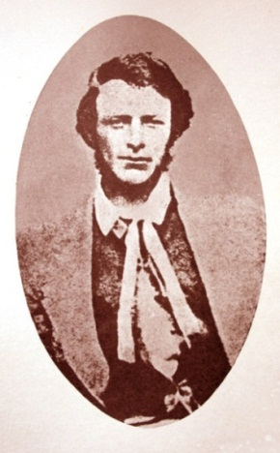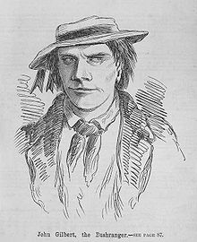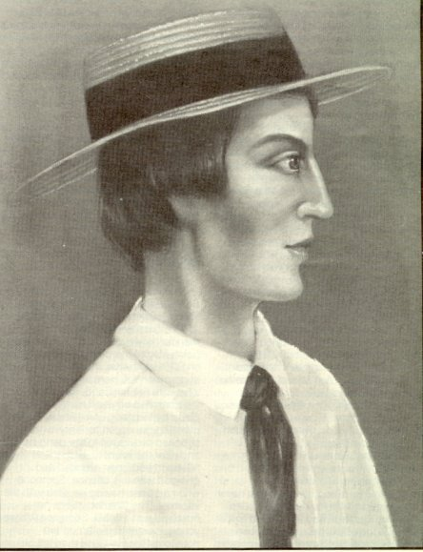
Ben Hall Johnny Gilbert John Dunn

Mr. Forbes proposed to ask witness whether he heard prisoner make any statement.

Mr. Walsh submitted that the proper course for the magistrate to cause the statement to be made by the prisoner to be taken down in writing, and not to take evidence of any person who heard the statement.

Mr. Forbes said that the written statement was that made after the prisoner had been cautioned, and the rule did not refer to a statement made during the course of the proceedings which was similar to a statement made at other times.

Mr. Walsh said: suppose the case of the magistrate saying to a prisoner that he would give him the opportunity of finding the person from whom he received the article mentioned; and he submitted that this would exclude a statement.

Witness to Mr. Walsh; what prisoner said was after Mr. Allman addressed him; Mr. Allman permitted the prisoner to say something.

To his Honor: The statement was invited by the magistrate; the prisoner wished to make a statement, and Mr. Allman said he might do so; the prisoner then said he got the cheque from Little Jack.

His Honor ruled this was not admissible.

To Mr. Forbes: What I heard the prisoner say was after Mr. Allman had spoken to the prisoner; I was not in the court before I was called as a witness.

To Mr. Walsh: the place where I saw prisoner and the bushrangers is, I believe Cramp’s; Cramp is son-in-law to the prisoner; I recognized Dunn; I was two or three hundred yards off; I had some conversation with the inmates of the house; some person connected to the house told me that the bushrangers came and ordered dinner; I may have said prisoner had said this; there are two meanings for the expression “the bushrangers ordered a dinner at a place” it is generally understood that they are asked to have a feed; in many cases is giving an act of compulsion.

To his Honor: I do not know any one named Wilson at Crookwell.
John James Allman deposed: I am a police magistrate; I presided when prisoner was committed for trial.

Mr. Forbes proceed to ask whether prisoner and statement before being spoken to.
Mr. Walsh objected.
Witness: The prisoner would insist on making several observations although defended by a lawyer; he was the most impracticable prisoner; he made voluntary statement; I put no question to him.
To Mr. Walsh: I request prisoner to be quiet as he was defended by a lawyer; after he mentioned the name of Wilson I remember saying we would give him an opportunity of finding Wilson.
To his Honor: Then it must be received in evidence.

Witness to Mr. Forbes: I have the distinct recollection that prisoner said he knew Mr. Wilson; I do not remember a man called Wilson having any case about horses taken from Tarago pound; I recollect the circumstances but not the name; I do not remember the man afterwards in the jail; Wilson is an unfortunate name so far as Goulburn jail is concerned; prisoner appeared to be labouring under the effects of drink when undergoing his examination at the Police court.

Constable Boon deposed: I was at Cramp’s place with Inspector Robert’s on 22nd January; I saw Dunn the bushranger and two others; prisoner was there walking about; all hands were outside; they did not appear to be like people stuck-up, but on friendly terms; prisoners daughter shook hands with Dunn.
The prisoner statement made at the police court on his committal was then put in and read. It was only “I have nothing to say”.

Mr. Walsh submitted that there was no case to go to the jury. There was no evidence that the cheque from Morriss was that given to Mrs. Siggs by the prisoner.

His Honor thought there was abundant evidence for the jury to believe this was the cheque. If they did not believe it they would not believe anything.

Mr. Walsh then addressed the jury for the defense. After the strong expression by his Honor he approached the case under considerable difficulty. The judge no doubt was a judge of the law, but not of the fact; and the question as to this cheque being the one stolen from Morriss was one of a fact. He assumed that there was no evidence to sustain the first count of the information. It was sought to lead the impression that the members of the prisoner’s family were sympathisers with the bushrangers; but the only evidence was that Mrs.’ Cramp had shaken hands with Dunn. On the other hand it was shown that compliant had been made to Inspector Roberts that the bushrangers had “ordered” their dinner. It was known that many persons, who would lose their lives, rather than do a dishonest act, had been compelled to extend their hospitality to the bushrangers. The real fact that the jury would have to determine was, not whether the cheque produced; was that stolen from Morriss which he would admit, but whether it was the cheque given to prisoner to Mrs. Siggs. Mr. Oakes had not been called as he might have been to prove that he never drew any other cheque in favor of Lachie Robertson. Mrs. Siggs could not identify as being paid to her; not could Craig, when his examination was continued, say that it was paid by Mrs. Siggs. The person who made the entry of the cheque in Mr. Emanuel’s books had not been called. He really must say that this was one of the most lame to get up a case against a prisoner of the crown prosecutor had ever made. There was nothing to show that prisoner had ever identified the cheque; and his statement about his getting the cheque from Wilson referred to only to whatever cheque he had given to Mrs. Siggs and not to the identical document before the police court which never went into his hands. He should be greatly surprised if the jury considered it established that the cheque produced was the same given by prisoner to Mrs. Siggs. But if they did, they would still have to consider whether knew that it was stolen. Why had he actually paid Mrs. Siggs the cheque while constable Benton was in the house; Bento being of all others most likely to detect him if he was guilty. The statement made by prisoner about Jack Wilson was made while he was under the influence of drink. In conclusion he again reminded that however great respect with which juries would listen to all that fell from judges; yet that juries were sole judges of the questions of the fact, and every British judge whenever he stated a question of fact would always tell the jury it was solely for their determination. As twelve responsible men he contended that the jury was just as capable as the twelve judges of England to say whether the cheque produced was that given to Mrs. Siggs.

Mr. Forbes replied. The learned advocate for the defense complained of the judge expressing an opinion on a manner of fact, whereas he had asked for this expression of opinion when submitting that there was no case for the jury. The prisoner had not at any time denied the cheque before the court that he had paid Mrs. Siggs but instead of disputing its identify confined himself to accounting for its possession. When, however, he was told that an opportunity would be afforded to him to find Jack Wilson, and when the statutory caution had been read to him his statement then was that, “he had nothing to say”

With respect to the supposed complaint of the bushrangers ordering dinner that must be remember that this was after Mr. Roberts had said that he had a mind to have them up for harbouring. He submitted the fact really was not that it must conclusively proved that the cheque passed to Mrs. Siggs was the one stolen form Morriss, but the cheque now produced and which was now admitted was passed by the prisoner, and this prisoner had acknowledged. Prisoner was charged with stealing the particular cheque produces and prisoner admitted he had had that cheque. After it was not necessary for the crown to show that Mr. Oakes had written any other cheques in favor of Mr. Robertson. It would have been for the prisoner to show that Mr. Oakes did so. As to the cheque being passed under the nose of the police it must be remembered that it was passed to a person who could not read or write.

His Honor summed up: He expressed his regret that the advocate for the defense should have commented so strongly on the expression of opinion he had given. He had given it entirely in answer to Mr. Walsh’s asking if there were no evidence to go to the jury. That was not a question of law at all. If in giving his answer he expressed hi opinion strongly it was because he felt strongly that there was such evidence. He had the right to express his opinion in what terms he liked; and should not attempt to justify himself; but wishing to sum up fairly as he could he would he would tell them whatever terms he might having expressed himself it was not to influence them. His Honor then explained the law relating to stealing and receiving, and proceeded to trace the history of the cheque and to go through the whole evidence affecting the prisoner.

The jury then retired to consider the verdict; and while the succeeding case was being proceeded with the prisoner (John Cairn) stated that Mr. Byrne, one of the jury in the (Payne’s) case had brought him a message from the prosecutor. This the latter denied. Thereupon the Judge, leaving the other jurors in the room, called Mr. Byrne into court and questioned him on the subject, though without swearing him in.

The jury having been absent for an hour were asked if they were likely to agree and replied they were not- that one of there number would not agree either way.
After a further absence of half an hour the jury came into court and asked if the prisoner had referred to the cheque as “the” or “a” cheque. His Honor said the expression sworn to was “the cheque.”

The jury then retired again, and in about a minute returned with a verdict of guilty on the second count.

Mr. Walsh said he thought it right to state the he should apply for a new trial. He should submit to the court that this was a mistrial. One of the jury, while deliberating, had been called out of the jury room into the court and this was separation of the jury. He should be prepared tomorrow to move his Honor for a new trial. Would his Honor require and affidavit of the fact, or consider that he had judicial knowledge of it.
His Honor said that he should not require an affidavit.

The prisoner was then remanded for sentence.

Thursday September 28, 1865

Charles Payne, prison number 2669 convicted on the previous day of feloniously receiving a stolen property was sentenced to ten years hard labour on the roads. He was incarcerated in Goulburn Gaol to await transfer to Darlinghurst Gaol and then on 10 October 1865, the prisoner was sent to the roads at Parramatta Gaol on 9th April 1865. Were the prisoner authorities of the day aware that this was his second criminal offence when they considered the length of the sentence of 10 years? When one considers that the cheque was only to the value of ₤3.7s or was greater weight given at the trial of harbouring bushrangers when sentencing Charles.

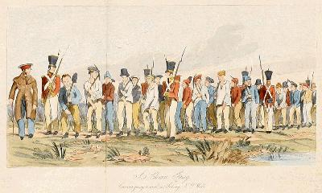

Iron Gang on the Roads

