Source: http://acms.sl.nsw.gov.au/item/itemDetailPaged.aspx?itemID=440059#

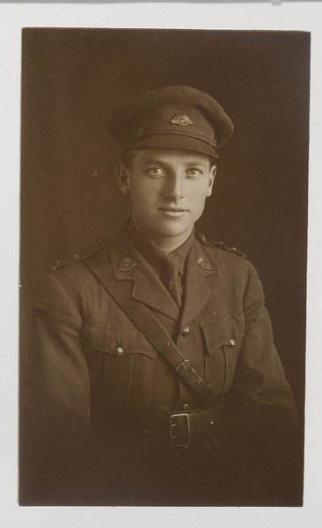

Title: NSW servicemen portraits, 1918-19 - Herbert Edward Whiteford
Call Number: P1 / Whiteford, Herbert Edward
Date of Birth: 25 Mar 1894
Date of Enlistment: 7.8.1914 and 23.5.1918
Trade or Calling: Commercial traveller
Born in or near what Town: Gundaroo via Queanbeyan NSW
Address prior to Enlistment: Burlington & Sophia Sts North Sydney
Rank, Number, Battalion, Distinctions: Lieut. N.13 GS Reinforcts 2nd Battalion
Casualties and where:
Name & Address of Next of Kin: Mrs Kathleen Whiteford Burlington & Sophia Sts North Sydney (Wife)
Name and last address of Father: Edward Stephen Whiteford Vincent St Cessnock
Biographical information taken from reverse of photograph

For additional information, refer to the Australian War Memorial (online), Biographical Databases, First World War Nominal Roll
NameWhiteford, Herbert Edward

